**Topics: Descriptive Statistics and Probability**

1. Look at the data given below. Plot the data, find the outliers and find out $μ, σ, σ^{2}$

|  |  |
| --- | --- |
| **Name of company** | **Measure X** |
| Allied Signal | 24.23% |
| Bankers Trust | 25.53% |
| General Mills | 25.41% |
| ITT Industries | 24.14% |
| J.P.Morgan & Co. | 29.62% |
| Lehman Brothers | 28.25% |
| Marriott | 25.81% |
| MCI | 24.39% |
| Merrill Lynch | 40.26% |
| Microsoft | 32.95% |
| Morgan Stanley | 91.36% |
| Sun Microsystems | 25.99% |
| Travelers | 39.42% |
| US Airways | 26.71% |
| Warner-Lambert | 35.00% |

* Outilier - Morgan Stanley - 91.36%
* Mean - 33.27133
* Vairance – 287.14
* Standard Deviation – 16.94

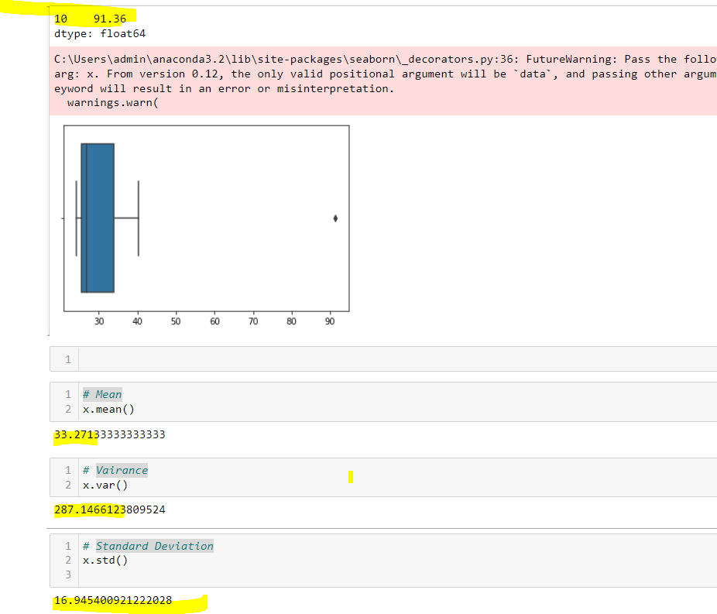



Answer the following three questions based on the box-plot above.

1. What is inter-quartile range of this dataset? (please approximate the numbers) In one line, explain what this value implies.
2. What can we say about the skewness of this dataset?
3. If it was found that the data point with the value 25 is actually 2.5, how would the new box-plot be affected?

1 – inter –quartile range = (Q3 – Q2) = (12 – 5) = 7

2 - Data is having positive skewness

3 There wouldn’t be any outlier and data would be normally distributed



Answer the following three questions based on the histogram above.

1. Where would the mode of this dataset lie?
2. Comment on the skewness of the dataset.
3. Suppose that the above histogram and the box-plot in question 2 are plotted for the same dataset. Explain how these graphs complement each other in providing information about any dataset.

1 – More data lies in the range of 0 to 10 (5 and 6 having highest data points)

2 – Data is positively skewed

3 In both boxplot and histogram data at Y value 25 , indicates outlier which drags distribution towards right causing Positive skewness .

1. AT&T was running commercials in 1990 aimed at luring back customers who had switched to one of the other long-distance phone service providers. One such commercial shows a businessman trying to reach Phoenix and mistakenly getting Fiji, where a half-naked native on a beach responds incomprehensibly in Polynesian. When asked about this advertisement, AT&T admitted that the portrayed incident did not actually take place but added that this was an enactment of something that “could happen.” Suppose that one in 200 long-distance telephone calls is misdirected. What is the probability that at least one in five attempted telephone calls reaches the wrong number? (Assume independence of attempts.)

**one in 200 long-distance telephone calls is misdirected**

**=>  probability of call misdirecting  p = 1/200**

**Probability of call not Misdirecting = 1 - 1/200 = 199/200**

**Number of Calls = 5**

**P(x) = ⁿCₓpˣqⁿ⁻ˣ**

**n = 5**

**p = 1/200**

**q = 199/200**

**at least one in five attempted telephone calls reaches the wrong number**

**= 1  -  none of the call reaches the wrong number**

**= 1  - P(0)**

**= 1   -  ⁵C₀(1/200)⁰(199/200)⁵⁻⁰**

**= 1  -  (199/200)⁵**

**= 0.02475**

**probability that at least one in five attempted telephone calls reaches the wrong number = 0.02475**

1. Returns on a certain business venture, to the nearest $1,000, are known to follow the following probability distribution

|  |  |
| --- | --- |
| x | P(x) |
| -2,000 | 0.1 |
| -1,000 | 0.1 |
| 0 | 0.2 |
| 1000 | 0.2 |
| 2000 | 0.3 |
| 3000 | 0.1 |

1. What is the most likely monetary outcome of the business venture?
2. Is the venture likely to be successful? Explain
3. What is the long-term average earning of business ventures of this kind? Explain
4. What is the good measure of the risk involved in a venture of this kind? Compute this measure

1 - most likely monetary outcome of the business venture  is 2000  $

as it has maximum probability = 0.3

X               P(X)     E(X)= X . P(X)     E(X²) = X² . P(X)

-2000       0.1         -200                400000

-1000        0.1         -100                 100000

0                0.2        0                        0

1000         0.2         200                200000

2000        0.3         600                1200000

3000        0.1          300                900000

                              800                 2800000

Expected value =  ∑E(X)P(X)  = 800

3 long-term average earning of business ventures  = 800 $

2 venture is  likely to be successful as Expected value is + ve   = 800 $

4 Var (X) = E(X²)  - {E(X) }²

=   2800000 -   800²

= 2160000  ( Quite High)

SD = √Var  ≈ $ 1470As Variability is Quite high  hence Risk is high